uname command in Linux with Examples

Linux, renowned for its open-source flexibility and powerful performance, offers a range of commands that reveal the inner workings of your system.
The 'uname' command stands out as a versatile tool that provides key details about your Linux machine.

What is 'uname' Command in Linux?
.The term "uname" stands for "Unix Name," and the command itself is designed to provide you with key details about your Linux system.
The answers you get can help you understand your system's kernel version, operating system, hardware architecture, and more. This command 'uname' displays the information about the system.

Syntax:

The basic syntax of 'uname' command is as follows:

uname [OPTIONs]

Options and Examples of 'uname' Command in Linux

Options | Description
'-a' or '--all' | Displays all available information.

Options | Description
'-s' or '--kernel-name' | Shows the kernel name.
'-n' or '--nodename' | Displays the network (domain) name of the machine.
'-r' or '--kernel-release' | Shows the kernel release.
'-v' or '--kernel-version' | Displays the kernel version.
'-m' or '--machine' | Shows the machine hardware name.
'-p' or '--processor' | Displays the processor type or "unknown."
'-i' or '--hardware-platform' | Shows the hardware platform or "unknown."
'-o' or '--operating-system' | Displays the operating system.

'-a' option in uname Command in Linux

It prints all the system information in the following order: Kernel name, network node hostname, kernel release date, kernel version, machine hardware name, hardware platform, operating system.
Syntax:

uname -a

Output:

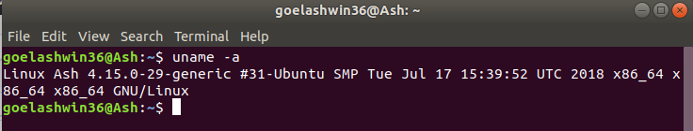

'-s' option in uname Command in Linux

It prints the kernel name. Syntax:
uname -s

Output:
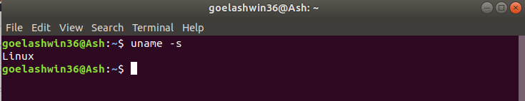

'-n' option in uname Command in Linux

It prints the hostname of the network node(current computer). Syntax:
uname -n

Output:
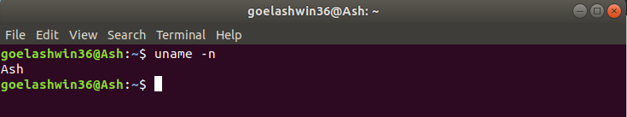

'-r' option in uname Command in Linux

It prints the kernel release date. This is useful for debugging or understanding the exact environment you're working in.
Syntax:

uname -r

Output:
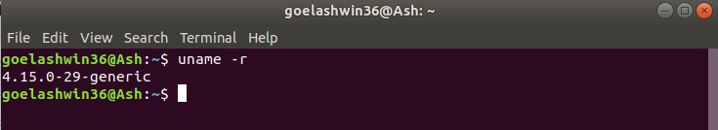

'-v' option in uname Command in Linux

It prints the version of the current kernel, including the build date and time. Syntax:
uname -v

Output:
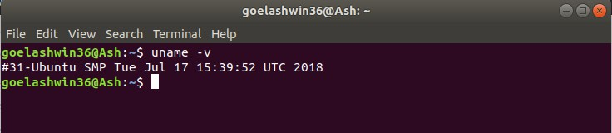

'-m' option in uname Command in Linux

It prints the machine hardware name of the machine, such as 'x86_64' for a 64-bit system.
Syntax:

uname -m

Output:
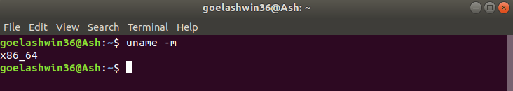

'-p' option in uname Command in Linux

It prints the type of the processor. Syntax:
uname -p

Output:
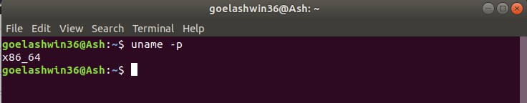

'-i' option in uname Command in Linux

It prints the platform of the hardware or "unknown" if it can't be determined.
Syntax:

uname -i

Output:
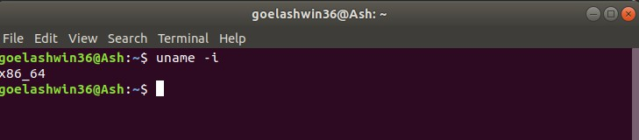

'-o' option in uname Command in Linux

It prints the name of the operating system running on the machine. Syntax :
uname -o

Output:
